**Chapter 4 Motion Controlling System**

The Motion Controlling subsystem is responsible for all the mechanical motion of the robot, following the commands determined by the development board. This subsystem can move forward/backward/left/right and rotate left/right horizontally. Also it can move upward and downward vertically.

The control commands from the development board are transmitted through a wireless module called XBEE using transparent mode or directly through the USB port on the development board.

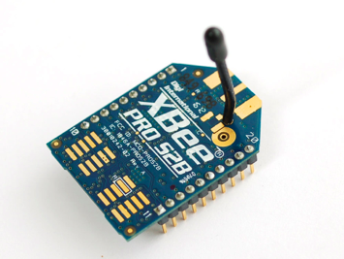

Figure[num] The XBEE wireless module

A well format communication protocol between the development board and the motion control subsystem is defined in our project.

struct IntelCarCmd

{

/*

starter indicates the start of the message

*/

uint8_t starter;

/*

0 indicates car movement, with rotation

1 indicates lifter movement. only up and down

2 indicates camera platform movement, with roll/pitch/yaw

3 indicates compass request

*/

uint8_t action_type;

/*

move distance

only meaningful when action_type = 0 or action_type = 1.

distance is measured in mm.

*/

uint16_t move_dis;

/*

move direction

only meaningful when action_type = 0 or action_type = 1.

for car, directions are up/right/down/left w.r.t 0/1/2/3

for lifter, directions are up/down w.r.t 0/2

*/

uint8_t move_dir;

/*

rotate angle

this field only meaningful when action_type = 0 or action_type = 2.

(degree * 100,say, if you are rotating 36.5, the rotate_degree would be 3650)

*/

uint16_t rotate_dis;

/*

rotate direction

this field only meaningful when action_type = 0 or action_type = 2.

ratate_dir = (MSB)XXXXXXXX(LSB).

when action_type = 1, all bits are 0s.

when action_type = 0 or 2, first 2 bits are 1s.

when third bit is 1 and fourth bit is 0, means roll left. when second bit is 1, means roll right.

when fiveth bit is 1 and sixth bit is 0, means pitch down. when second bit is 1, means pitch up.

when sixth bit is 1 and last bit is 0, means yaw counterclockwise. when second bit is 1, means yaw clockwise.

*/

uint8_t rotate_dir;

/*

check_sum = action_type + (move_dis >> 8) + (move_dis & 0xff) + move_dir + (rotate_dis >> 8) + (rotate_dis & 0xff) + rotate_dir

*/

uint8_t check_sum;

};

In order to deal with packet lost or packet damaged problem, an ACK message is defined.

struct ACK

{

/*

starter indicates the start of the message

*/

uint8_t starter;

uint8_t O; //0x4f

uint8_t K; //0x4B

uint8_t check_sum; //0x9A

};

The Motion Controlling System or the car can be separated into four major parts.

1. Control Board
2. Lifter
3. Camera Platform
4. Motion Platfrom

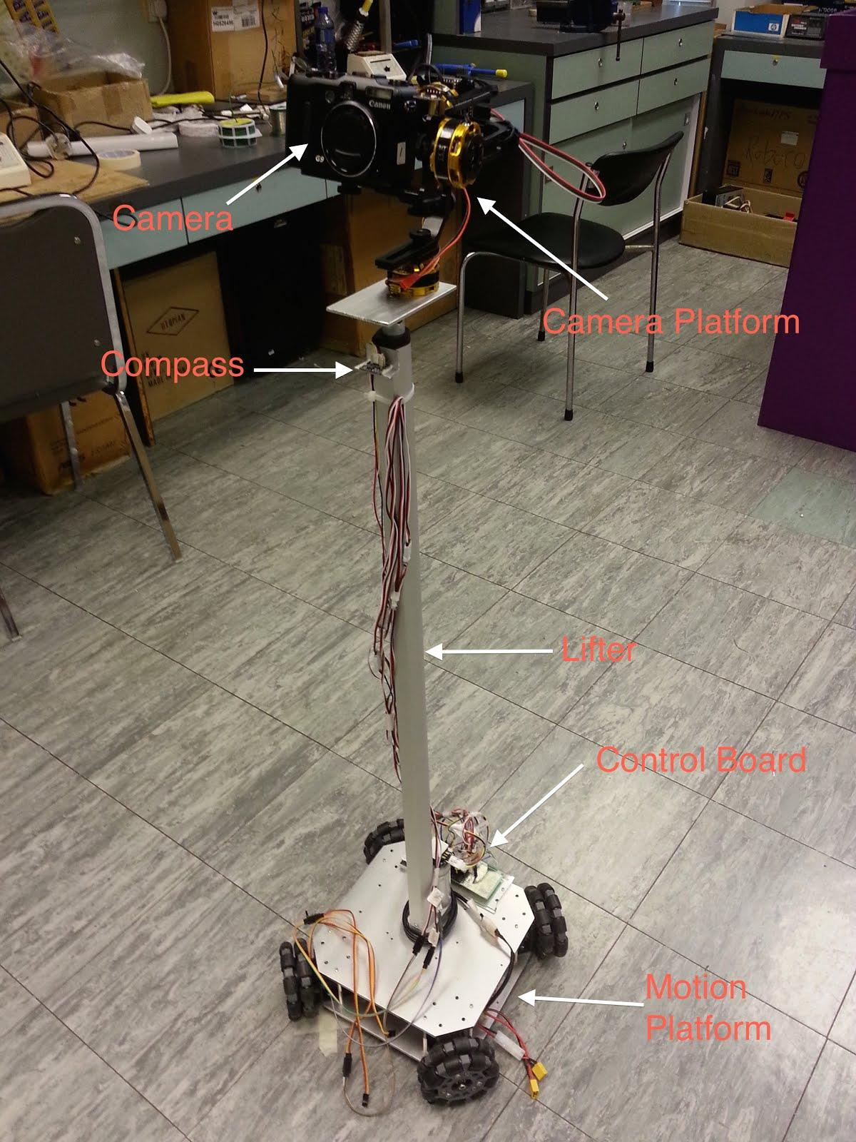

figure[num] The Motion Controlling System

-Control Board

The Control Board is an rapid prototyping mebedded system developed by ‘mbed’[1]. The MBED board provides multiple UART ports and I2C ports which meet our requirement rather that the Galileo board. The control board retrieves the command messages from the XBEE wireless module through the UART port periodically. It will respond to different commands correspondingly like forwarding the command to the Motion Platform, set Lifter up or down, or control the Camera Platform.

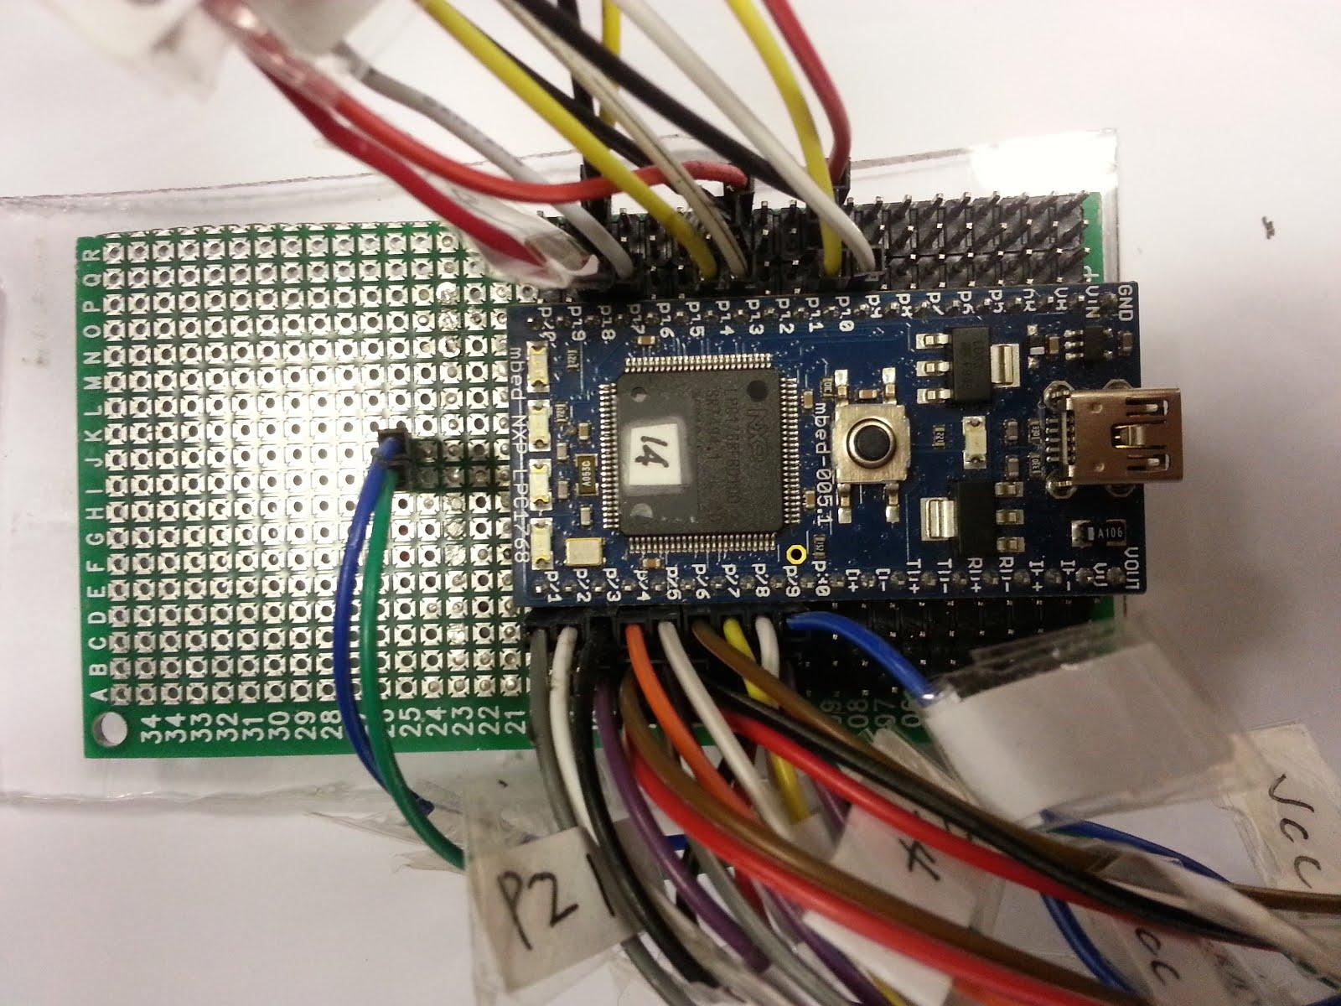

figure[num] The Control Board

-Motion Platform

The Motion Platform is an open source project provide by Nexus Robot[2]. After modified the source code, the Motion Platform can also respond to the command message forwarded by the control board correctlly, like moving forward or backward, moving left or right, or rotate left or right. We also do some upgrade in our project in order to enlarge the payload capacity of the motion platform.

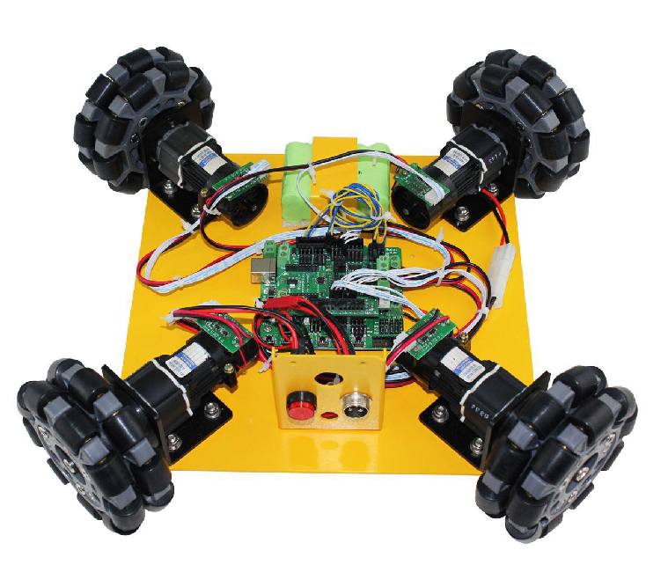

figure[num] The Motion Platform

-Lifter

The Lifter is controlled by the control board. The lifter can move upward or downward. The maximum displacement of the lifter is 700 mm. Since the lifter require a 12V-4A power supply, a H-bridge in needed.

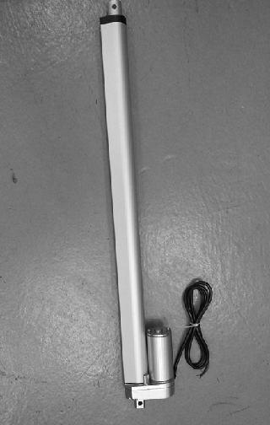

figure[num] The Lifter

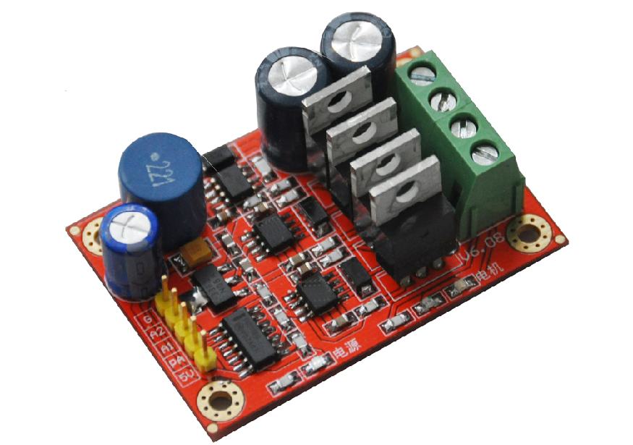

figure[num] The H-Bridge

-Camera Platform

The Camera Platform provide 2 or 3 degrees of freedom to the camera such that the camera can roll, pitch or even yaw.

There are two kinds of camera platform in our project. The first is based on servo motor with 2 degrees of freedom (roll and pitch) and the second one is based on brushless motor with 3 degrees of freedom and self-balancing function.

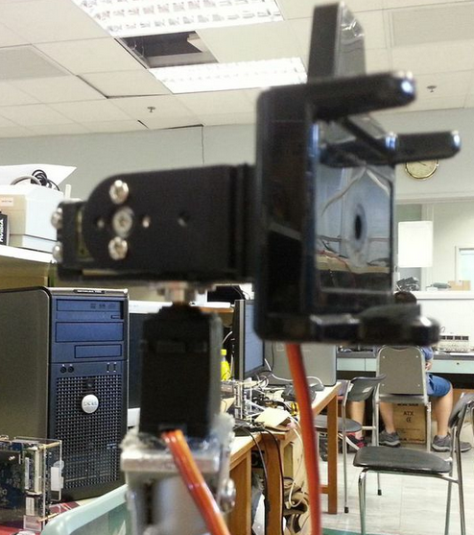

figure[num] The Camera Platform with 2 degrees of freedom

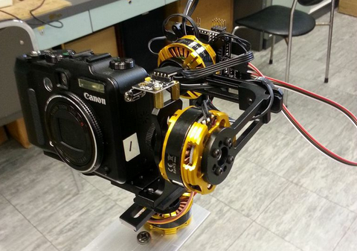

figure[num] The Camera Platform with 3 degrees of freedom

Reference:

[1]<http://mbed.org/>

[2][www.nexusrobot.com](http://www.nexusrobot.com)